Design &Analysis of Algorithms
Project Overview

Delivered to: Dr. Rabie A. Ramadan

Project Team Members:
- Ayman Mohamed Abo El-Maaty Sec:1 B.N:7

Introduction

The purpose of this document is to provide a guideline and an overview for the Design & Analysis of Algorithms project results.

Phase01 Database & GUI Inputs:

The goal of this phase is to set a simple GUI for the users of the program, as choosing what type of operation they prefer to commit according to the view which differs according to the user type (Lecturer-Student-Admin).

As well as the Database including the ER-Diagram and the Relational Diagrams for the Database used for saving the user records, which was better to use that the file organization mechanism which will make a lot of problems in inserting or updating data, as well as globalization if the project is developed to be a web application used by set of users at same time.

Phase02 Core Design:

The goal of this phase is to set a data-structure that is used in the project, as the project was working on java IDE, which has set of difficulties to implement a graph without using an outer library to do so.

The Maps are used instead with Course Code is the Key to Identify each Course, the Maps are preferable than sets for its Key assigned for each data node which is ordered by the Key while the set will make some difficulties to retrieve a value of a node saved in that set.

Trees weren’t used as the trees are Acyclic Directive Graph while the Problem description makes sense with an undirected Graph.

The Phase has the Main idea that the coloring algorithm is built on it, the Main Domain are settled by the Courses of the System, as each course has it’s free time corresponding to it, as the algorithm go on, the constraints are made due to the conflict happening for 2 courses, for each iteration the closest course that can be assigned by the first free slots of each course, then propagate the constraint according to the data or structural hazard, which is a different way compute the dependency.

Phase03 Output GUI:

The goal of this phase is to Show the outputs of the previous phase as the Time Table, Graph Drawing and the Conflict Table and exporting the results to external files.

Some Screen Shots of the program:

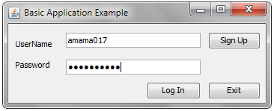
Log in Frame

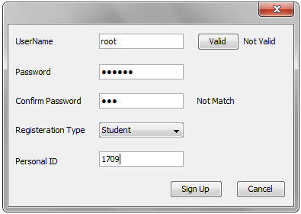
Registration
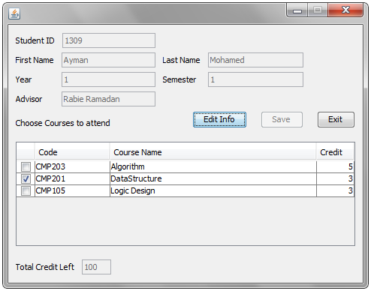
Student View

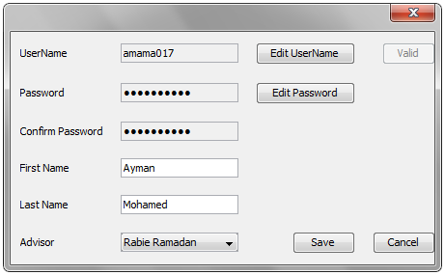
Student Data Entry

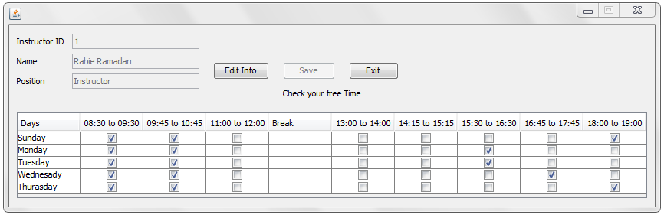
Lecturer View

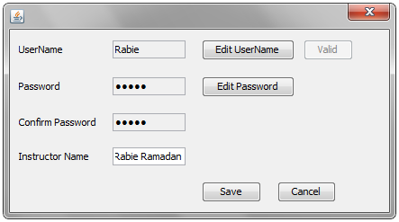
Lecturer Data Entry

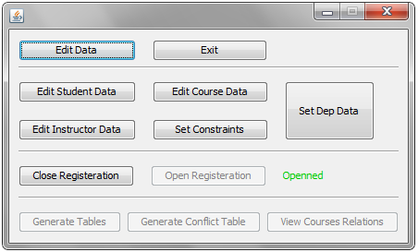
Admin View

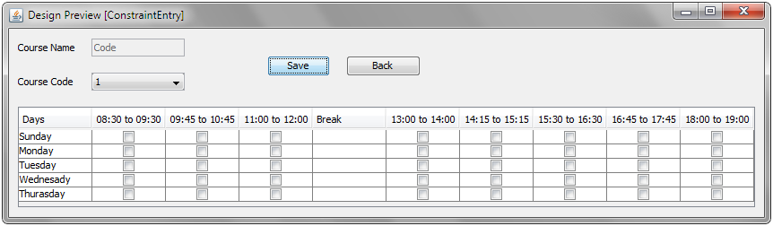
Course Constraints Entry

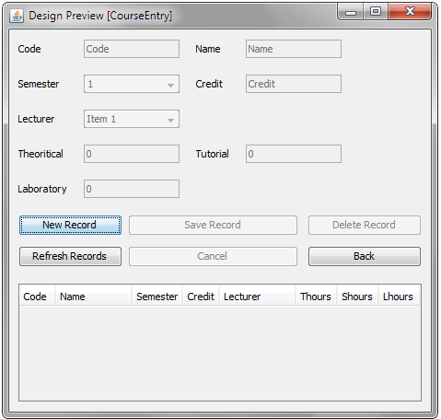
Course Data Entry

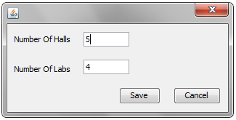
Department Data Entry

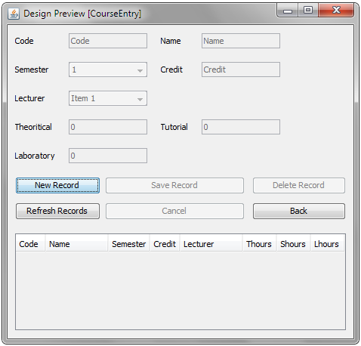
Lecturer Record Manager

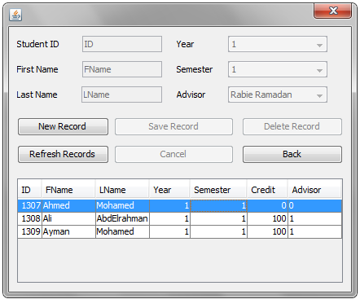
Student Record Manager

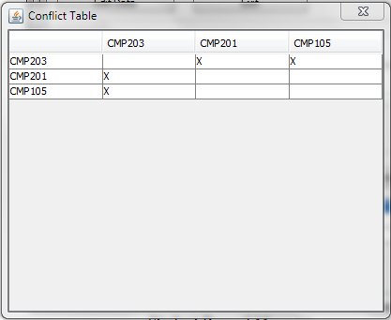
Sample Conflict Table

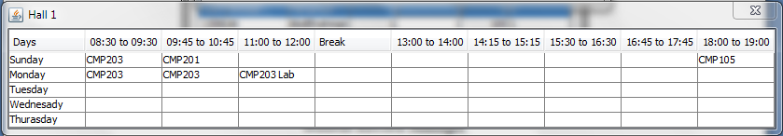
Sample Time Table #1

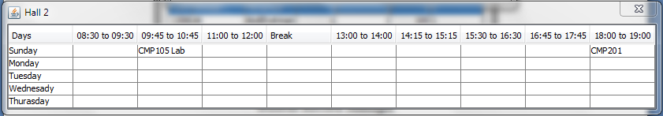
Sample Time Table #2

Conclusions:

The project is working with low efficiency as the set of requirements is still unavailable for the user to use, the real state of the project is saved by the last status of the project in “Project Status.doc” file containing the headlines set of uncompleted requirements.

